1. 7th Small Congress of CNIRS TMF “Stefan Đokić” 2024
At this year's Congress, students of the Faculty of Technology and Metallurgy presented 21 scientific research papers in the fields of biochemical engineering and biotechnology, chemical engineering, materials engineering, as well as environmental engineering.
Kristina Fidanović, student ID number 2020/0290, participated on March 28th and 29th, 2024, in the 7th Small Congress of CNIRS TMF “Stefan Đokić” held in the Grand Hall of the Faculty of Technology and Metallurgy, with a paper titled “Nutritional and Functional Properties of Protein-Enriched Dough from Green Leaf Biomass”.
Ružica Simović, student ID number 2020/0128, participated on March 28th and 29th, 2024, in the 7th Small Congress of CNIRS TMF “Stefan Đokić” held in the Grand Hall of the Faculty of Technology and Metallurgy, with a paper titled “Production of Bioactive Peptides by Conventional and In Silico Hydrolysis of RuBisCO Fractions”.
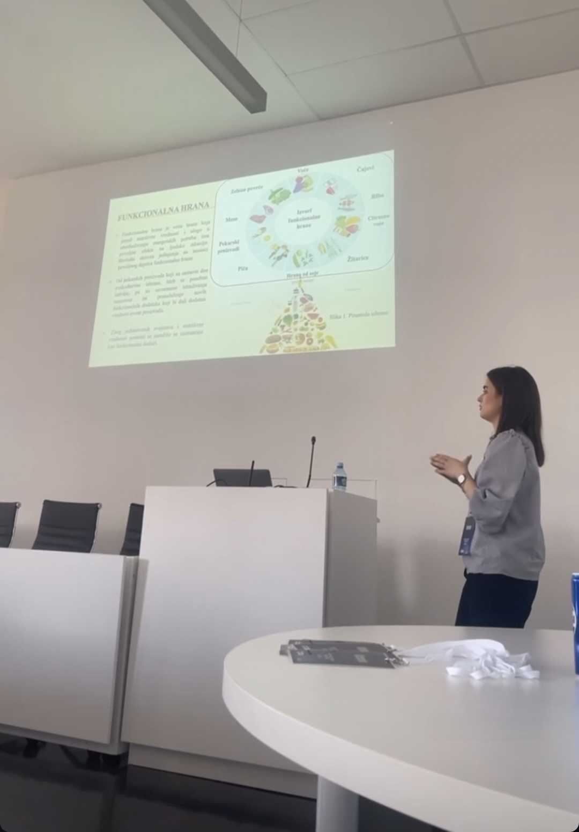
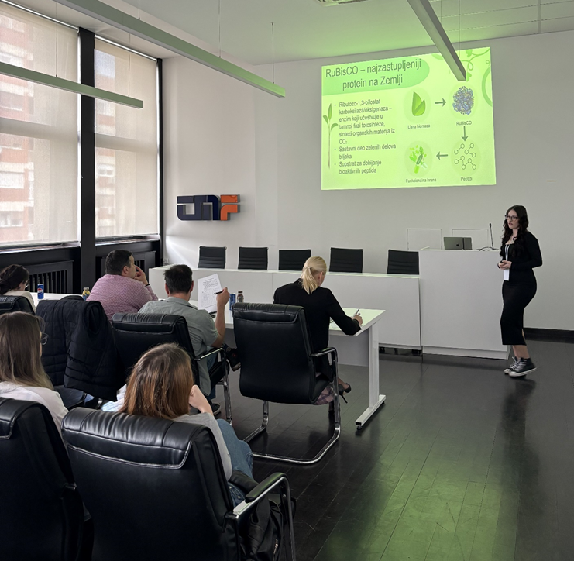

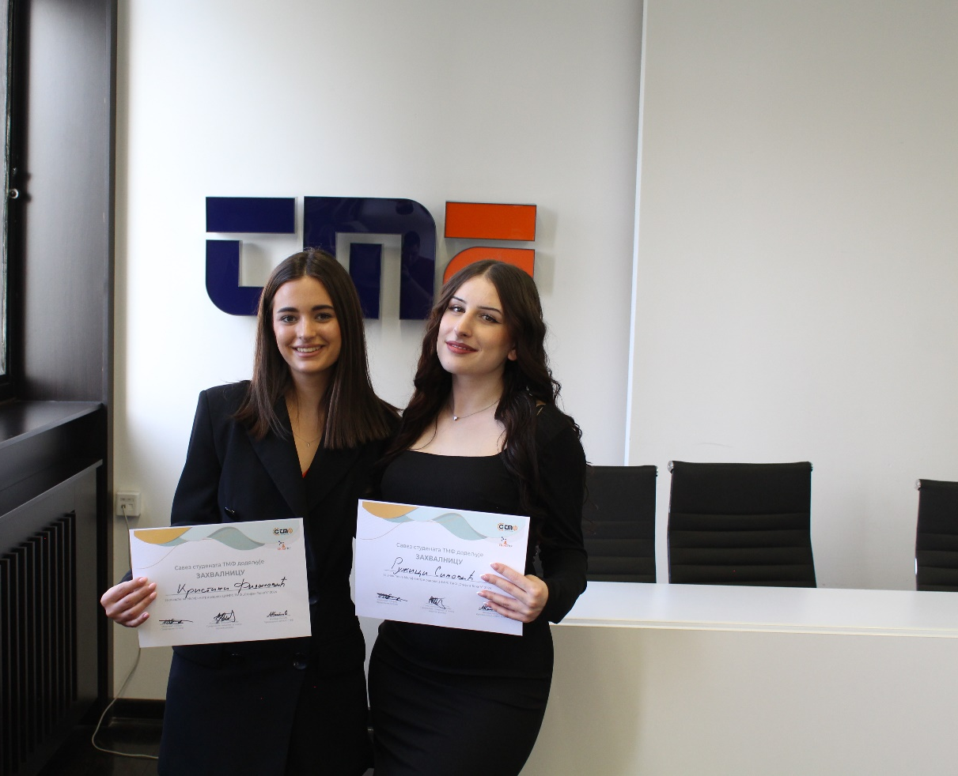

2. 6th Congress of CNIRS TMF “Milica Nektarijević” 2023
At this year’s Congress, students of the Faculty of Technology and Metallurgy presented 20 scientific research papers in the fields of biochemical engineering and biotechnology, chemical engineering, materials engineering, as well as environmental engineering.
Dora Mikašinović, student ID number 2020/0001, participated in the 5th CNIRS TMF Congress “Stefan Đokić”, held on Monday, 26th October 2023, at the Science and Technology Park Belgrade, with a paper titled “Engineering of RuBisCO Protein Nanoparticles for Targeted and Controlled Vitamin B12 Release”. At this prestigious competition of student research, Dora was awarded the bronze medal.
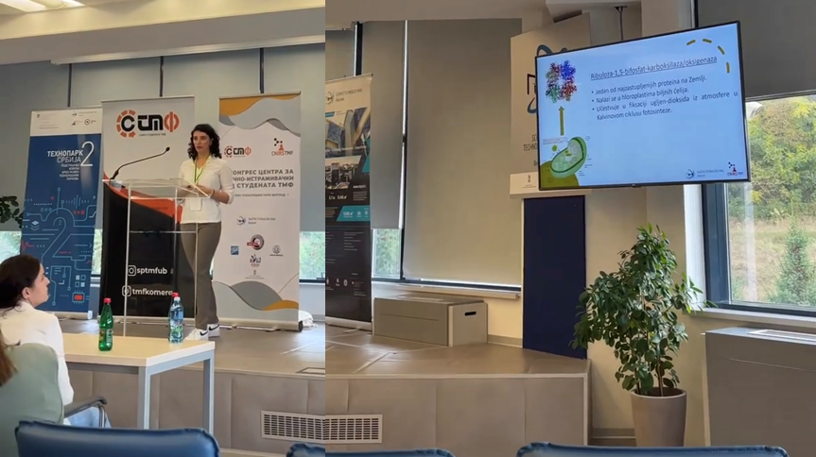
Anja Malović (student ID number 2019/0119) and Joka Nikolić (student ID number 2019/0300) participated in the 5th CNIRS TMF Congress “Stefan Đokić”, held on Monday, 26th October 2023, at the Science and Technology Park Belgrade, with a paper titled “Pumpkin Leaf Protein-Based Complex Coacervates for Controlled Delivery of Folic Acid”. This research was recognized with the Best Presentation Award at the congress.
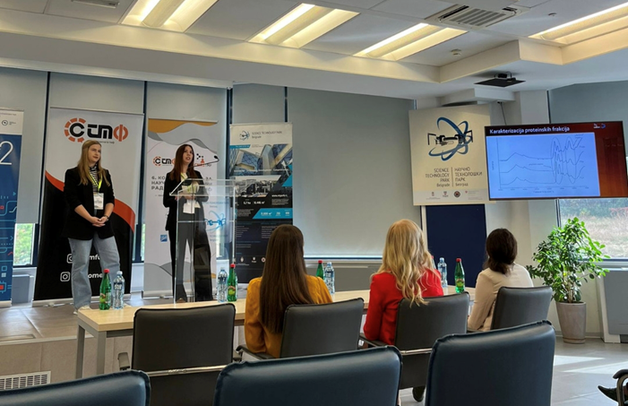
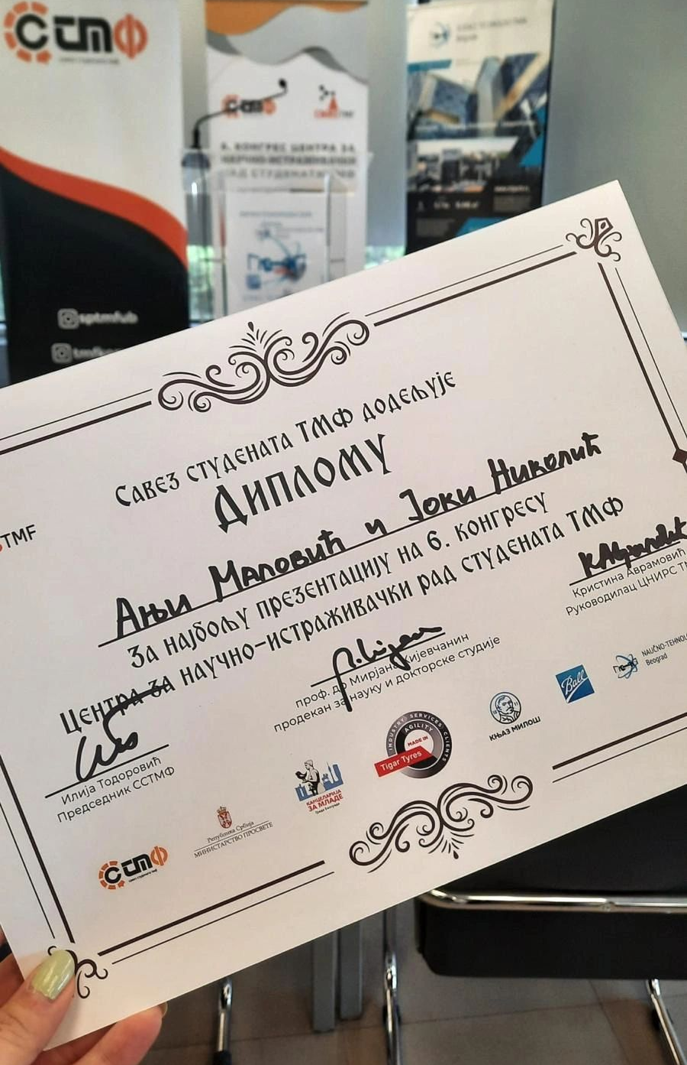

3. 5th Congress of CNIRS TMF 2022
At this year’s Congress, students of the Faculty of Technology and Metallurgy presented 20 scientific research papers in the fields of biochemical engineering and biotechnology, chemical engineering, materials engineering, as well as environmental engineering.
Gavrilo Mihajlović, student ID number 2018/0084, participated in the 5th CNIRS TMF Congress “Stefan Đokić”, held on Monday, 5th December 2022, at the Science and Technology Park Belgrade, with a paper titled “Ultrasonic Method for Enhanced Protein Extraction from Pumpkin Cucurbita pepo Leaves”.
Olivera Vukoičić, student ID number 2018/0111, participated in the 5th CNIRS TMF Congress “Stefan Đokić”, held on Monday, December 5th, 2022, at the Science and Technology Park Belgrade, with a paper titled “Leaf-Derived Proteins as Natural Carriers for Nutrient Encapsulation”.
